Proficiency test through interlaboratory comparison
Emission of harmonic currents in the 50 Hz to 2000 Hz frequency range
Scheme of the proficiency test PTC(HARM-CUR-50-2000)

Carlo Carobbi
Università degli Studi di Firenze, Dipartimento di Ingegneria dell’Informazione, Firenze, ITALY

Rev. 0 – February 12, 2021: first issue of the scheme.
Rev. 1 – February 25, 2021: Annex A and Annex B modified including request of digital signature and date.
Rev. 2 – March 18, 2021: Annex A modified to meet requirements of Italian law (Decreto Semplificazioni, DL n. 76, dated 16/07/2020) for payments through Sistema PagoPA.
Rev. 3 – April 19, 2021: clause 6 modified adding the rated voltage of the Sample, see paragraph 6.b).

- Scope

  - This document describes the participation scheme to a proficiency test performed through an interlaboratory comparison of measurements of harmonic currents emission in the 50 Hz to 2000 Hz frequency range. The scheme includes:

- The description of the interlaboratory comparison;
- The selection criteria of the participants and the terms of admission to the proficiency test;
- The description of the technique adopted for the statistical analysis of the results of the interlaboratory comparison;
- The instructions to the participating laboratory (briefly, Laboratory) on how to perform measurements;
- The description of the method by which the results of the proficiency test are registered by the Laboratory and by the Coordinator of the proficiency test;
- The test report forms to be filled by the Laboratory and by the Coordinator;
- The registration forms (Doodle link for selecting the week for measurements, the purchase order regulating the agreements between the Laboratory and the Coordinator).

  - The last revision of the present document can be downloaded from the following URL:
https://www.dinfo.unifi.it/vp-436-schemes-of-the-proficiency-tests.html

- Coordinator

  - The Coordinator of the proficiency test is Carlo Carobbi, from Università degli Studi di Firenze. The Coordinator relies on the technical and scientific support from:
- Alessio Bonci, ITT G. Ferraris (San Giovanni Valdarno, Arezzo, ITALY),
- Marco Cati, Powersoft S.p.A. (Scandicci, Firenze, ITALY).

  - The contact details of the Coordinator are reported below:

Carlo Carobbi
Università degli Studi di Firenze, Dipartimento di Ingegneria dell’Informazione
Via S. Marta, 3 – 50139 Firenze, ITALY
Office phone: +39 055 2758501
Mobile phone: +39 329 6509116
e-mail: carlo.carobbi@unifi.it
skype: live:carlo.carobbi
Telegram: https://t.me/carlo_carobbi

- Type of interlaboratory comparison

  - The interlaboratory comparison consists in the comparison of the measurements of a travelling standard (Sample) provided by the Coordinator. Each Laboratory makes a quantitative examination (measurement) of the Sample thus providing the Coordinator with a measurement result.

  - The Coordinator designed and assembled the Sample.

  - The Coordinator assigns to the Sample a reference value and the corresponding uncertainty. The reference value, , and its standard uncertainty, , are obtained by the Coordinator through the statistical analysis of the measurement results provided by the Laboratories during the proficiency test. The reference value and the standard uncertainty will be known at the end of the proficiency test, after that the last participating Laboratory has submitted its measurement results.

  - The scheme of participation in the proficiency test is sequential and it is illustrated in Fig. 1. The Coordinator passes the Sample to the 1st participating Laboratory. The 1st Laboratory performs the measurement thus obtaining the 1st measurement result. Then, the 1st Laboratory passes the Sample to the 2nd Laboratory which, in turns, performs the measurement and determines the 2nd measurement result. The 2nd Laboratory passes the Sample to the 3rd Laboratory which obtains the 3rd measurement result, and so on. The last Laboratory passes back the Sample to the Coordinator. The proficiency test is completed when the last participating Laboratory has submitted its measurement result to the Coordinator.

  - The measurement result provided by each Laboratory consists of current measured values x at given harmonic orders (and corresponding frequencies). Harmonic orders are selected by the Coordinator. The measurement results provided by each Laboratory shall be compared, harmonic by harmonic, against the reference values assigned by the Coordinator (see below).

  - The transmission of the test report from the Coordinator to the Laboratory will take place only after that the proficiency test is concluded. No communication of the results of the proficiency test shall be done by the Coordinator to the Laboratory in the time period comprised between the beginning and the conclusion of the proficiency test.

  - The participation fee is specified in the purchase order (Annex A – Italian for Italian participants, or Annex B – English for non-Italian participants).
Last Lab
j^{th} Lab
COORDINATOR
1st Lab
2nd Lab
i^{th} Lab
Fig. 1: Sequence by which the Sample is shipped from the Coordinator to the Laboratories and from the Laboratories to the Coordinator.
  - The Laboratory has one (1) week available to perform the measurement and one (1) week to communicate the measurement result to the Coordinator. Late results will not be accepted nor processed by the Coordinator.

  - In case that a Laboratory is willing to submit more than one set of measurement results (e.g. because the Laboratory wants to assess the performance of different facilities and instrumentations) then the Laboratory shall contact the Coordinator in order to determine the appropriate scheduling, participation fee and a correspondingly modified purchase order. In such case more than one test report shall be issued by the Laboratory, one for each submitted set of measurement results. Any request for more than one test report must be individually evaluated by the Coordinator (the Laboratory shall contact the Coordinator to this purpose), and it will imply, if viable, a higher cost (500 Euro for any additional test report).

  - It is intended that the subscription of the purchase order reported in Annex A (Italian) or Annex B (English) allows for the submission of a single test report, both by the Laboratory and by the Coordinator.

- Admission requirements

  - The present scheme applies to Electromagnetic Compatibility (EMC) test Laboratories that can perform harmonic currents emission measurements in accordance to the method described in §6.3 of EN 61000-3-2:2019, in the frequency range from 50 Hz to 2 kHz (from the fundamental to the 40th harmonic of 50 Hz).

  - Accreditation to ISO/IEC 17025 is not required for admission to the proficiency test. The Coordinator designed the present scheme assuming participation of both accredited and non-accredited Laboratories.

  - The Coordinator starts the proficiency test if there are at least five participating Laboratories. The maximum number of participating laboratories is twenty-five (25) which corresponds to a total duration of the proficiency test of less than one year.

  - The Coordinator assigns a code to the Laboratory for anonymous identification. The same code will be used to identify the Laboratory in e-mail correspondence and in the test reports. The code is as follows:

PTC(HARM-CUR-50-2000)LAB(#)

The code is the combination of a general part – PTC(HARM-CUR-50-2000) – that identifies the measurement method, and therefore a homogenous set of measurement results, and a specific part – LAB(#) – that identifies a particular Laboratory.

  - The Laboratory that is willing to participate in the proficiency test shall:

- Fill, print, sign, scan and send by certified e-mail to the certified e-mail address dinfo@pec.unifi.it the purchase order in Annex A (Italian) or Annex B (English). It is generally intended that Italian laboratories use Annex A, foreign laboratories use Annex B.

- Designate a Technical Responsible. The Technical Responsible shall sign the test report submitted by the Laboratory to the Coordinator (Annex C), in addition he/she will be the reference person for correspondence with the Coordinator.

- Select the week during which the measurement will be performed by using the Doodle link
https://doodle.com/poll/645s7hins6nibbk5 Use the Laboratory name when making the selection, do not use the code assigned by the Coordinator.

  - The Laboratory shall observe the following shipping rules:
- Shipping of the Sample from the Coordinator to the Laboratory is in charge of the Coordinator;
- Shipping of the Sample from Laboratory X to the next Laboratory Y or to the Coordinator is in charge of Laboratory X;
- Shipments shall be done by means of an express courier;
- The same packaging used by the Coordinator shall be used by the Laboratory.

Address and contact details of each Laboratory are provided through the same Doodle link. Be accurate when inserting the address and contact details requested by the Doodle.

  - Handle with care the travelling Sample. A damage to the Sample will cause a delay and eventually the interruption of the proficiency test. Each Laboratory shall verify by inspection the mechanical integrity of the Sample. Possible defects or damages, proven or suspected, shall be immediately notified to the Coordinator. A verification of the electrical performance of the Sample is also envisaged (see §7).

- Statistical analysis of the measurement results

  - The measurement result provided by each Laboratory shall be compared against the reference value and its standard uncertainty . The assessment of the performance of the Laboratory is based on the z-score (symbol , see §9.4.1 of ISO 13528:2015). The measurement result provided by the i-th Laboratory (, where p is the number of participating Laboratories) is compared with the robust mean and robust standard deviation assigned by the Coordinator as follows

.

The value of is calculated for each Laboratory and for each investigated frequency. Therefore as many values of will be calculated as the number of investigated frequencies (for example, ten frequencies investigated, ten values of for the i-th Laboratory). The measurement result provided by the i-th Laboratory will produce a warning signal if, at least at one frequency, we have less than −2 or greater than +2. The measurement result provided by the i-th Laboratory will produce an action signal if, at least at one frequency, we have less than −3 or greater than +3. If at all frequencies, we have greater than −2 and less than +2 then the measurement result provided by the i-th Laboratory will not give evidence of any anomaly. Warning signals do not add up to give an action signal.

  - The values of and are obtained by the Coordinator by using the robust analysis (Algorithm A) described in Annex C of ISO 13528:2015, §C.3.1. The robust analysis is based on an iterative calculation. At the first step of iteration

and

.

NOTE: The factor 1,483 which appears in represents the ratio between the standard deviation and the median of the absolute deviations from the median, MAD, assuming normal distribution. It is indeed possible to show that in the case of symmetric distribution, , where is the cumulative distribution function. In the case of normal distribution and therefore .

- Characteristics of the Sample

  - The Sample is a non-linear device absorbing an active power of nearly 40 W at a rated voltage of 230 V (rms). It essentially consists of a full wave rectifier and a resistive-capacitive load.

NOTE: If considered as an as Equipment Under Test then emission limits are not specified for the Sample according to EN 61000-3-2:2019 (other than a lighting equipment and rated power less than 75 W).

  - The Sample is designed for being powered at the fundamental frequency of 50 Hz and rated voltage of 230 V (rms).

  - When powered the Sample generates harmonic currents from 50 Hz to 2 kHz at 50 Hz steps, however only odd harmonics are considered in this interlaboratory comparison. Even harmonics have small amplitude and are neglected.

  - The Coordinator identifies the harmonics to be measured and reported through their order. For example: the harmonic current of order 5 is at the approximate frequency of 250 Hz.

  - The Sample requires at least 1 min warm-up after being powered. Do not carry out measurements before warm-up time is elapsed.

  - The amplitudes of the harmonic currents generated by the Sample are stable. A test observation period T_{obs} of 10 s is sufficiently long to achieve the measurement repeatability specified in §6.3.3.1 of EN 61000-3-2:2019.

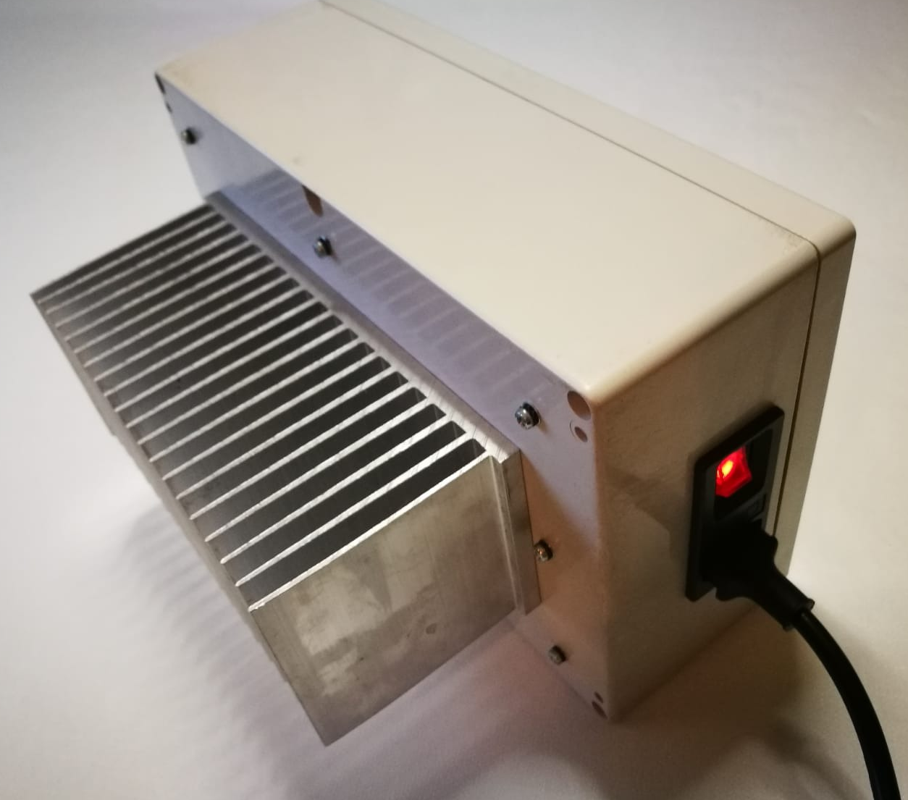 | 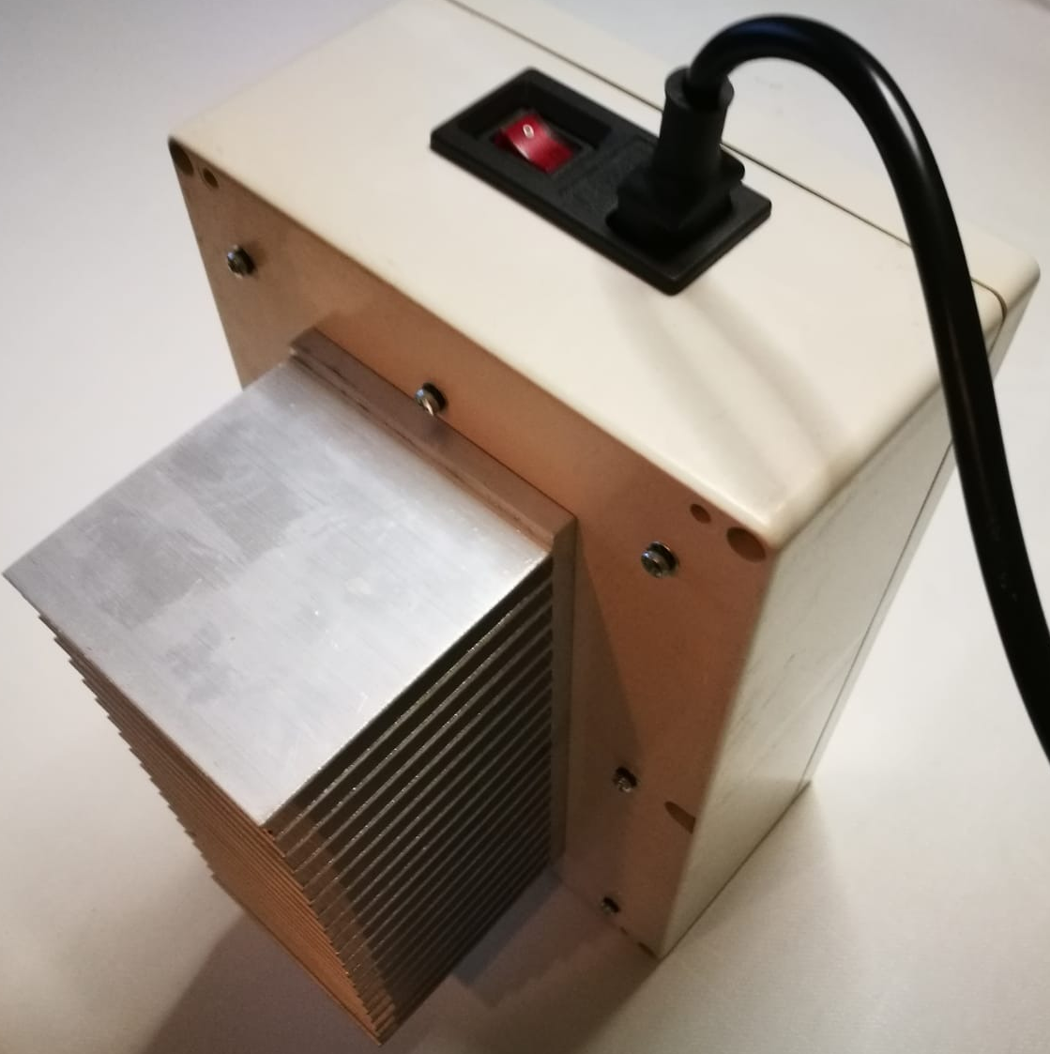

Fig. 2: Picture of the Sample-

  - The Sample is enclosed in a case. The combination of the lock locking the case is 183. Input the figures from top to bottom.

Fig. 3: Picture of the lock.

- Measurement procedure

  - Harmonic currents measurement is carried out according to §6.3 of EN 61000-3-2:2019.

  - Set the test observation period T_{obs} = 10 s.

  - After measurement check that the value of the harmonic of order 1 (at the 50 Hz fundamental frequency) is 200.00 mA ± 20.00 mA. If the measured value is outside the specified 180.00 mA to 220.00 mA interval, then immediately contact the Coordinator. The interlaboratory comparison is temporarily postponed until the cause of this out-of-tolerance measured value is clarified and appropriate corrective actions are undertaken.

- Recording harmonic currents measurement results

  - The Laboratory shall use Annex C in order to report measurement results to the Coordinator.

  - The measured harmonic current x, expressed in milliampere (mA), shall be rounded to 2 decimal figures (e.g. 25.32 mA).

  - Report the average value of the amplitude of the harmonic current x taken over the entire test observation period.

  - The value of x shall be recorded in the fourth column of Table 1. The Coordinator will complete the rest of Table 1 when issuing the test report (outcome, see Annex D) to the Laboratory.

Table 1: Table to be used for recording the harmonic currents measurement results. Column four shall be filled up by the Laboratory, the other columns (two, three and five) will be filled up by the Coordinator.

1 | 2 | 3 | 4 | 5
Harmonic  order | x*  mA | s*  mA | x  mA | z
3 | - | - |  | -
7 | - | - |  | -
11 | - | - |  | -
15 | - | - |  | -
19 | - | - |  | -
23 | - | - |  | -
27 | - | - |  | -
31 | - | - |  | -
35 | - | - |  | -
39 | - | - |  | -

  - The proficiency test result does not give evidence of any anomaly if, at all harmonic orders, . Otherwise anomalies shall be described in terms of warning and action signals as discussed in §5.

- Test reports

  - The test report issued by the Laboratory to the Coordinator shall conform to Annex C and it shall be signed by the Technical Responsible or his/her Deputy, see 4.e). The test report issued by the Coordinator to the Laboratory will conform to Annex D. Annexes C and D, once completed by the Laboratory and by the Coordinator, will be integral part of the present document and they will provide evidence to any interested part (e.g. the Accreditation Body) of the participation of the Laboratory to the proficiency test.

  - The test report shall include the following additional information:
    - The result of the verification of the amplitude of the harmonic current of order 1 (see §7.c);
    - The observation period T_{obs};
    - A description of the measurement equipment (brand, model, serial number or internal classification);
    - At least one picture of the measurement setup.

- Remarks and complaints

  - The Coordinator issued and made freely available this document in order to prevent remarks and complaints from the Laboratories during the progress of the proficiency test.

  - Remarks and complaints will be considered by the Coordinator only if they are related to management or technical aspects relevant to the proficiency test but not considered in the present document. Subscription of the purchase order in Annex A (Italian) or B (English) implies formal acceptance of the terms and conditions of participation in the proficiency test described in this document.

  - Laboratories can verbally contact (e.g. by phone) the Coordinator to represent possible remarks and complaints about management and technical problems related to the proficiency test that appear during the progress of the proficiency test itself. If possible and depending on the importance of the problem originating the remark or complaint, the Coordinator will give advice to the Laboratories in order to resolve the problem.

  - If the Coordinator judges that the problem cannot be verbally solved through an advice to the Laboratory, then he will ask the Laboratory a written communication of the remarks and complaints. The Coordinator will discuss the remarks and complaints with his technical and scientific collaborators (see §2) and collectively take a decision about their management.

  - Possible technical problems related to the management of the Sample (including shipment), delay in the progress of the proficiency test caused by a Laboratory or by the Coordinator himself, can be solved by the Coordinator without involving the scientific and technical collaborators.

- Confidentiality and impartiality

  - The Coordinator and his technical and scientific collaborators shall keep confidential any information pertaining the performance of the Laboratories involved in the proficiency test during its progress and after its completion. The Coordinator warrants that the results originated from the participation of the Laboratories in the proficiency test shall be kept confidential through:

- Keeping anonymous the result associated with each Laboratory. The individual result produced by each Laboratory may be released only in such a way that the anonymity of the Laboratory is preserved.

- Keeping anonymous aggregate results (i.e., statistical average, dispersion, …). The aggregate proficiency test results may be released only in such a way that the anonymity of the Laboratories that generated the results is preserved.

- Informing accredited Laboratories about a possible request of the Accreditation Body to reveal their proficiency test result. The proficiency test result shall be revealed to the Accreditation Body under written permission of the accredited test Laboratory.

  - The Coordinator and his scientific and technical collaborators will avoid any conduct that could cause some Laboratories to take advantage with respect to the others in the successful participation in the proficiency test.

  - Laboratories shall avoid raising issues that could generate a situation of disparity in the successful completion in the proficiency test.

Annex A

Compilare inserendo i dati richiesti oppure impiegare modello di buono di acquisto equivalente avendo cura, in particolare, di specificare le informazioni evidenziate in giallo. Verificare di aver inserito i dati richiesti e spedire il buono di acquisto a dinfo@pec.unifi.it
_________________________________________________________________

ORDINE DI ACQUISTO PER PRESTAZIONI A TARIFFA
(in conformità all’art.3 c. del Regolamento sullo svolgimento di attività di ricerca o didattica commissionate da soggetti pubblici e privati emanato con D.R. 451/2018, Prot. 63016 del 16/04/2018)

N° Documento:  Data:  Data di consegna del rapporto di prova: entro 1 anno dalla data di emissione del presente ordine di acquisto  (altre info richieste dal Committente) | Indirizzo del Dipartimento:  Università degli Studi di Firenze  Dipartimento di Ingegneria dell’Informazione, Via Santa Marta, 3 – 50139 Firenze, Italia | Indirizzo di fatturazione: | Indirizzo di consegna del campione itinerante:
Con riferimento al tariffario del Dipartimento di Ingegneria dell’Informazione approvato in data 30 gennaio 2019, il Committente affida l'incarico per le prestazioni di seguito descritte:
Descrizione | Quantità | Prezzo unitario | Importo Netto
Partecipazione a circuito interlaboratorio tipo E, codice PTC(HARM-CUR-50-2000) | 1 | 1500 Euro | 1500 Euro
 |  | Valore netto | 1500 Euro
 |  | IVA | 330 Euro*
 |  | Importo totale | 1830 Euro
* Specificare l’eventuale titolo di inapplicabilità dell’IVA
Firma digitale del Committente

___________________

****
CONDIZIONI GENERALI DI ACQUISTO
- Ambito di applicazione
Le presenti "Condizioni generali di acquisto" si applicano a tutte le prestazioni su tariffario effettuate dal Dipartimento a favore di Committente. Le presenti condizioni prevarranno su eventuali condizioni generali o particolari di vendita del Dipartimento. Qualsiasi modifica o aggiunta alle presenti Condizioni sarà valida soltanto nel caso di specifica accettazione scritta del Committente. Le modifiche e le integrazioni alle Condizioni saranno limitate alla particolare prestazione per la quale vengono pattuite.

- Responsabile dell’attività
Responsabile dello svolgimento della prestazione è il Prof. Carlo Carobbi

- Emissione degli Ordini di Acquisto
L'Ordine di Acquisto si intende accettato dal Dipartimento e quindi perfezionato, all'atto della ricezione da parte del Committente della Conferma d'Ordine sottoscritta per accettazione dal Dipartimento, purché detta ricezione avvenga entro il termine di 15 giorni dalla data di emissione dell'Ordine.

- Termini e modalità di esecuzione della prestazione
- La prestazione richiesta dovrà essere svolta dal Dipartimento entro e non oltre 1 anno dalla data di emissione dell’ordine di acquisto.
- La prestazione richiesta dovrà essere svolta dal Dipartimento secondo le modalità descritte dal documento tecnico “Proficiency test through interlaboratory comparison Emission of harmonic currents in the 50 Hz to 2000 Hz frequency range Scheme of the proficiency test PTC(HARM-CUR-50-2000)”, la cui ultima revisione è disponibile presso la pagina web https://www.dinfo.unifi.it/vp-436-schemes-of-the-proficiency-tests.html, e che il Committente integralmente accetta.
- Il Dipartimento deve puntualmente rispettare i termini e le modalità di invio del campione itinerante. La consegna del campione itinerante dovrà avvenire presso la sede indicata nella voce "Indirizzo di Consegna" riportata nell'Ordine di Acquisto.
- In caso di ritardo nelle consegne di quanto pattuito, il Committente avrà il diritto di fissare al Dipartimento un termine ulteriore per la consegna.

- Corrispettivi e pagamenti
- Salvo diversi accordi scritti, i prezzi indicati nell'Ordine di Acquisto si intendono fissi e non soggetti ad alcuna revisione.
- Inoltre, ai sensi dell'articolo 1260 del C.C., il credito derivante dall'esecuzione del presente ordine non potrà essere oggetto di cessione o di delegazione, sotto qualsiasi forma.
- Per la liquidazione delle fatture, le stesse dovranno obbligatoriamente riportare il numero dell'Ordine di Acquisto e gli altri eventuali riferimenti in esso riportati.
- Il pagamento dell’importo totale indicato (indicare l’eventuale titolo di inapplicabilità dell’IVA) verrà effettuato dal Committente entro 30 giorni dal ricevimento di fattura elettronica – codice SDI destinatario ………….. e indirizzo PEC ………………………… in conformità a quanto previsto dal Decreto Semplificazioni (DL n. 76 del 16/07/2020) esclusivamente attraverso l’utilizzo del Sistema pagoPA. Ogni pagamento sarà identificato univocamente dal codice IUV (Identificativo Univoco di Versamento), generato in sede di creazione della fattura e notificato al Committente tramite un Avviso di Pagamento contenente anche il Codice Avviso di Pagamento, il Codice QR e il Codice Interbancario (circuito CBILL: AAB1Y) che consentono di effettuare il pagamento.
- Il Dipartimento terrà in ogni caso il Committente indenne e manlevato da ogni e qualsivoglia danno, perdita, costo o spesa (ivi incluse eventuali sanzioni comminate ai sensi di legge) che possano ad esso derivare da eventuali violazioni e/o inadempimenti del Dipartimento agli obblighi previsti dal presente articolo. In tutti i casi di inadempimento del Dipartimento, il Committente avrà il diritto di sospendere i pagamenti dovuti al Dipartimento, senza che ciò determini la maturazione di alcun interesse o penalità, finché il Dipartimento avrà rimediato all'inadempimento.

- Trattamento dei dati
I dati forniti dalle Parti saranno trattati per le finalità del presente Ordine di acquisto, nel rispetto dei principi di liceità, correttezza, trasparenza, adeguatezza, pertinenza e necessità di cui all’art. 5, paragrafo 1 del Regolamento Generale sulla Protezione dei Dati (GDPR). Il conferimento di tali dati tra le Parti è obbligatorio al fine di adempiere a tutti gli obblighi di contratto comunque connessi all’esecuzione del rapporto instaurato con il presente atto.
I medesimi dati potranno essere comunicati unicamente all’interno della struttura del Committente e del Dipartimento per la gestione del rapporto instaurato dal presente atto.
I dati forniti dalle Parti saranno raccolti e trattati, con modalità manuale, cartacea e informatizzata, mediante il loro inserimento in archivi cartacei e/o informatici.
L’informativa completa dell’Università di Firenze sulla protezione dei dati personali degli operatori economici relativi al presente contratto è disponibile al seguente link https://www.unifi.it/upload/sub/protezionedati/Informativa_TERZI.pdf
L’informativa completa del Committente sulla protezione dei dati personali degli operatori economici relativi al presente contratto è disponibile al seguente link …………………., ovvero allegata al presente ordine.
Titolari del trattamento sono l’Università degli Studi di Firenze e il Committente e, Referenti per la protezione dei dati sono il Direttore del Dipartimento per l’Università e ……………… per il Committente.

CONFERMA D’ORDINE

VI CONFERMIAMO IL PRESENTE ORDINE ALLE CONDIZIONI SOPRA INDICATE CHE DICHIARIAMO DI ACCETTARE SENZA RISERVE

Firma per accettazione
Il Direttore del Dipartimento di Ingegneria dell’Informazione

_____________________________________

Annex B

Fill the required fields or use a similar purchase order providing equivalent information. Please specify an email address for administrative correspondence (see the text highlighted in yellow). Check that the required information has been inserted then send the purchase order to carlo.carobbi@unifi.it
_________________________________________________________

PURCHASE ORDER FOR FEE-BASED SERVICES
(in accordance with art.3 c. of the Regulation on the performance of research or teaching activities commissioned by public and private entities issued by Regional Decree 451/ 2,018, Prot. 63016 of 16/04/2018)

Document N°: Date:  Delivery date of the test report: by 1 year from the date of issue of this purchase order  (other information requested by the Client) | Department address University of Florence  Department of Information Engineering, Via Santa Marta, 3 – 50139 Firenze, Italia | Invoicing address: | Delivery address  of the travelling sample:
With reference to the price list of the Department of Information Engineering approved on the 30th of January 2019, the Client hereby commissions the services described below:
Description | Quantity | Unitary price | Net amount
Participation in interlaboratory comparison type E, code PTC(HARM-CUR-50-2000) | 1 | 1500 Euro | 1500 Euro
 |  | Total amount | 1500 Euro

Date and digital signature of the Client
____________________

****
GENERAL CONDITIONS OF PURCHASE

Scope of application
These "General Conditions of Purchase" shall apply to all services on a fee basis performed by the Department in favour of the Client. These Conditions shall prevail over any general or special conditions of sale of the Department. Any amendments or additions to these Conditions shall be valid only if specifically accepted in writing by the Client. Amendments and additions to the Conditions shall be limited to the specific service for which they are agreed.

Person in charge of the activity
The person responsible for the performance of the service is Prof. Carlo Carobbi

Issue of Purchase Orders
The Purchase Order shall be deemed as accepted by the Department, and therefore completed, upon receipt by the Client of the Order Confirmation signed for acceptance by the Department, provided said receipt occurs within 15 days from the date of issue of the Order.

Terms and conditions of the service
  - The requested service must be provided by the Department by and no later than 1 year from the date of issue of this purchase order.
  - The requested service shall be carried out by the Department as described in the technical document “Proficiency test through interlaboratory comparison Emission of harmonic currents in the 50 Hz to 2000 Hz frequency range Scheme of the proficiency test PTC(HARM-CUR-50-2000)”, whose latest revision is available on the web page https://www.dinfo.unifi.it/vp-436-schemes-of-the-proficiency-tests.html, and that the Customer fully accepts.
  - The Department must comply with the terms and methods of shipment of the travelling sample. Delivery of the travelling sample shall be made to the location indicated in the "Delivery Address" section of the Purchase Order.
  - In the event of delay in the delivery terms agreed upon, the Client shall have the right to fix another term for the delivery with the Department.

Fees and payments
  - Unless otherwise agreed in writing, the prices set forth in the Purchase Order are fixed and not subject to revision.
  - Furthermore, pursuant to article 1260 of the Italian Civil Code, the credit deriving from the execution of this Purchase Order shall not be subject to assignment or delegation in any form whatsoever.
  - In order to be paid, invoices must include the number of the Purchase Order and any other references indicated therein.
  - Payment shall be made by the Client within 30 days from receipt of billing notice which will be followed by regular invoice – sent to the email address .............................. – by payment to IBAN code IT88A0200802837000041126939, BIC/SWIFT: UNCRITM1F86, care of the UNICREDIT Banca S.p.A. in favour of the University of Florence - Department of Information Engineering (U.A. code 58507).
  - In any case, the Department will hold the Client harmless and indemnified from any and all damages, losses, costs or expenses (including any penalties imposed by law) that may be incurred as a result of the Department's breach and/or non-fulfilment of its obligations under this article. In all cases of default by the Department, the Client shall have the right to suspend payments due to the former, without the accrual of any interest or penalty, until such time as the Department has remedied the non-fulfilment.

Data processing
The data provided by the Parties shall be processed for the purposes of this Purchase Order, in accordance with the principles of lawfulness, fairness, transparency, adequacy, relevance and necessity set forth in Article 5, paragraph 1 of the General Data Protection Regulation (GDPR). The provision of such data between the Parties is compulsory in order to fulfil all contractual obligations in any case connected to the execution of the relationship established by this deed.
The same data may only be communicated within the structure of the Client and the Department for the management of the relationship established by this deed.
The data provided by the Parties shall be collected and processed manually, on paper and by computer, via their inclusion in hard-copy and/or computer files.

ORDER CONFIRMATION

WE CONFIRM THIS ORDER AT THE ABOVE CONDITIONS WHICH WE DECLARE TO ACCEPT WITHOUT RESERVATION

Signature for acceptance
The Director of the Department of Information Engineering

_________________________________

Annex C
Page … of …

Test report
Issued by the participating Laboratory – Proficiency test code PTC(HARM-CUR-50-2000)

Laboratory: Name of the Laboratory
Laboratory Code: PTC(HARM-CUR-50-2000)LAB(#)
Address: Address of the Laboratory
Technical Responsible: First name and last name of the Technical Responsible or his/her Deputy
E-mail: E-mail address of the Technical Responsible or his/her Deputy
Phone: Phone number of the Technical Responsible or his/her Deputy
Date of issue: Date of issue of this test report

Date of Sample receipt: .......................................................
Date of measurements: ...........................................................
Data of Sample shipment: ..................................................

Test result

Fill in the empty cells of column four with the measured value x.

1 | 2 | 3 | 4 | 5
Harmonic  order | x*  mA | s*  mA | x  mA | z
3 | - | - |  | -
7 | - | - |  | -
11 | - | - |  | -
15 | - | - |  | -
19 | - | - |  | -
23 | - | - |  | -
27 | - | - |  | -
31 | - | - |  | -
35 | - | - |  | -
39 | - | - |  | -

Comments, description and pictures of the setup shall be inserted here (see §9.b).

Sign of the Technical Responsible or his/her Deputy

....................................................................................

Annex D
Page … of …

Test report no. XYZ
Issued by the Coordinator of the proficiency test code PTC(HARM-CUR-50-2000)

Carlo Carobbi
Dipartimento di Ingegneria dell’Informazione
Università degli Studi di Firenze
Via S. Marta, 3 – 50139 Firenze
Office phone: +39 055 2758501
Mobile phone: +39 329 6509116
e-mail: carlo.carobbi@unifi.it
to the participating Laboratory
Laboratory: Name of the Laboratory
Laboratory Code: PTC(HARM-CUR-50-2000)LAB(#)
Address: Address of the Laboratory

Start and stop dates of the proficiency test:
Number of participants:
Date of measurements of the participating Laboratory:
Data of issue of this report:
Test result
The cells of column four are filled in by the Laboratory, the other ones are filled by the Coordinator.

1 | 2 | 3 | 4 | 5
Harmonic  order | x*  mA | s*  mA | x  mA | z
3 | - | - |  | -
7 | - | - |  | -
11 | - | - |  | -
15 | - | - |  | -
19 | - | - |  | -
23 | - | - |  | -
27 | - | - |  | -
31 | - | - |  | -
35 | - | - |  | -
39 | - | - |  | -

Outcome
Here the Coordinator inserts the applicable outcomes:
- No anomaly is detected
- Warning signal(s) is (are) detected
- Action signal(s) is (are) detected
Sign of the Coordinator

...................................

